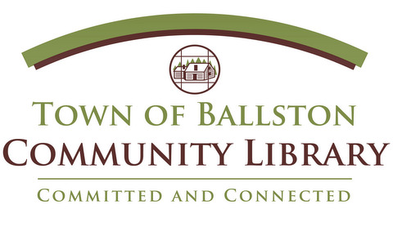
Date Received:
Staff Initials:
Date Approved:
Staff Approval:

Community Room Request Form
Organization: _________________________________________________________
Please list the dates and times you would like to use the Community Room. When possible please let us know your first and second choice for times and dates. You may book the Community Room up to ninety days in advance. We will do our best to accommodate all requests. The library will respond within three business days to let you know if your event has been approved.
Event 1 Dates/Times Requested:
1st Choice: ______________________________________________________
2nd Choice: ______________________________________________________
Event 2 Dates/Times Requested:
1st Choice: ______________________________________________________
2nd Choice: ______________________________________________________
Event 3 Dates/Times Requested:
1st Choice: ______________________________________________________
2nd Choice: ______________________________________________________

I received a copy of the Library’s Community Room Policy and agree to abide by the guidelines set out in the policy. I understand that set up and clean up are the responsibility of our group.

Signature of Responsible Party: __________________________________________

Contact Name: ________________________________________________________
Contact Phone: ________________________________________________________
Contact Email: _________________________________________________________

Town of Ballston Community Library (518) 399-8174
2 Lawmar Lane, Burnt Hills, NY 12027 http://toblibrary.sals.edu

