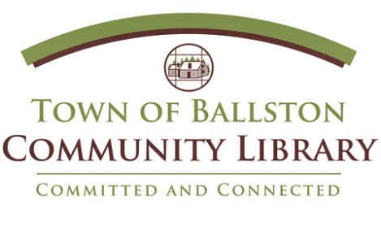
The Town of Ballston Community Library has re-opened the search
for a new Librarian II Head of Adult Services/Circulation position.
This individual must have a passion for creating an environment that encourages patrons to follow their interests, discover new ones, learn from their peers, and of course, embrace reading. He/she must possess effective communication skills and experience providing customer and reference service. He/she must also have experience creating and conducting innovative programs. The ability to communicate, coordinate, transition and promote library services as a team player and leader among staff is essential.
This Librarian will also provide excellent customer service in training staff and patrons on handheld devices, including iPads, Kindles, Nooks, and Android based systems. In addition, this Librarian must possess the interpersonal and communication skills that will enable them to represent the Library to the community.
Knowledge of traditional reference services, electronic reference, e-Books, programming, library technology, marketing and public speaking is required.
MLS and a minimum of 2 years post MLS library experience required. There is no current Saratoga County Librarian II Civil Service list. The successful applicant will take the exam when it is offered, and must be reachable on the list. Needs to have or be eligible to receive NYS Public Library Certification.
The Head of Adult Services/Circulation Librarian reports to the Director of the Library, supervises the public services areas and systems – including circulation, interlibrary loan, reserves, and stack maintenance, and participates as a member of the management team. Starting Salary: $41,500 – increases to $45,000 after one year. Benefits available through the Town of Ballston.
Applications accepted until position is filled. Resumes and three references may be sent to Library Director, Karen DeAngelo, at kdeangelo@sals.edu or mailed to
2 Lawmar Lane, Burnt Hills, NY 12027.

Responsibilities include:
- Interviewing, training, and supervising the Circulation staff
- Assisting patrons and adjudicating conflicts
- Providing reference services
- Performing all Circulation Desk duties including but not limited to checking out
and renewing
- Library materials, placing holds, collecting fines and fees, responding to patron
requests
- Responsible for adult programming and outreach
- Responsible for all publicity for the library using a wide variety of social media and print resources.
- Interlibrary Loan
The successful candidate will have:
- Experience supervising and evaluating staff
- ALA-accredited Masters of Library Science degree
- Experience with Polaris ILL
- Expertise in use of e-readers, Microsoft Office Applications. Experience teaching these topics is highly desirable.
- Excellent communication skills, computer proficiency, a commitment to providing superior service and the ability to handle multiple tasks in a busy environment.
- Excellent teamwork, project management, and conflict resolution skills
- Experience with Evanced, Constant Contact, and WordPress a plus

