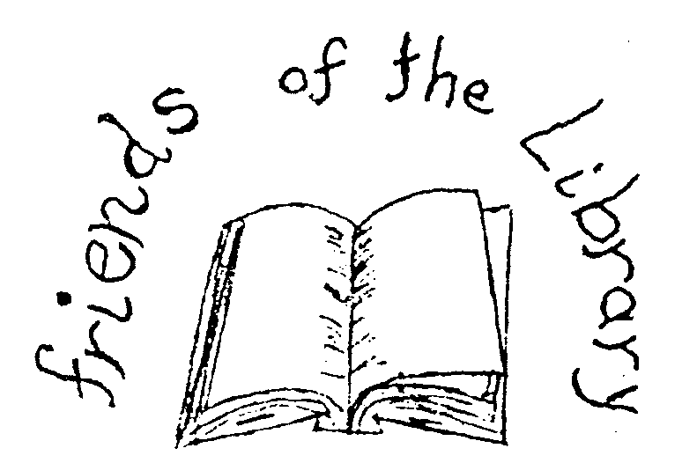
Friends of the Town of Ballston Community Library
2 Lawmar Lane, Burnt Hills, NY 12027
518-399-8174 http://toblibrary.sals.edu

Please fill out the following and send along with a check to:
Friends of the Town of Ballston Community Library
2 Lawmar Lane
Burnt Hills, NY 12027

Please Print or Type
Company Name _________________________________________________
Email Address ___________________________________________________
Company Address _______________________________________________
__________________________________________________________________
Company Representative ________________________________________
Contact Phone Number _________________________________________

By signing below you are agreeing to sponsor the Friends of the Library Mini Golf Event and you will pay and deliver in full the amount outlined in the sponsorship letter by February 1, 2012.

____________________________________________ _____________________
Signature of Authorized Representative Date

